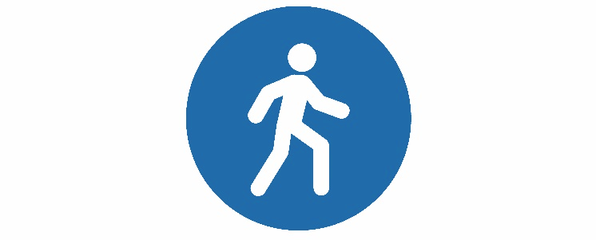

Stay Vertical, Calaveras

CLASS SCHEDULE – SUMMER
Each unit goes for 16 classes and participants are expected to complete all 16 classes.
~ CLASSES START ON TIME ~
All classes are provided FREE through a grant from the Mark Twain Health Care District.
If you are a returning exerciser, please sign up through your instructor.
Any new participants fill out the form below, including the class you want.

Community | Description | Day | Time | Location | Start
Angels Camp | Tai Chi | Mon & Wed | 10:30 am  CANCELLED | The Body Shop | July 8
Arnold | Strength Training | Mon & Wed | 9:30 am | Behind Independence Hall | July 8
Murphys | Strength Training | Mon & Wed | 9:00 am | Murphys Senior Center | On-Going
Murphys | Tai Chi | Mon  Thurs | 1:00 pm  10:30 am | Murphys Senior Center | July 8
Murphys | Tai Chi | Mon & Wed | 9:00 am | The Diggins | July 10
Murphys | Parkinson’s Tai Chi | Fri | 9:00 am | Murphys Senior Center | closed
San Andreas | Tai Chi &  Seated Tai Chi | Tues & Thurs | 9:00 am | Town Hall | July 9
Valley Springs | Strength Training | Mon & Wed | 10:45 am | Power Up! Fitness | July 8
Valley Springs | Tai Chi | Tue & Fri | 9:45 am | Power Up! Fitness | July 9
Valley Springs | Strength Training | Tues & Thurs | 9:30 am | United Methodist Church | July 9
Valley Springs | Tai Chi | Mon & Wed | 9:15 am | United Methodist Church | July 8

If you need more info please call 209-915-2450 or contact stayverticalcalaveras@gmail.com

