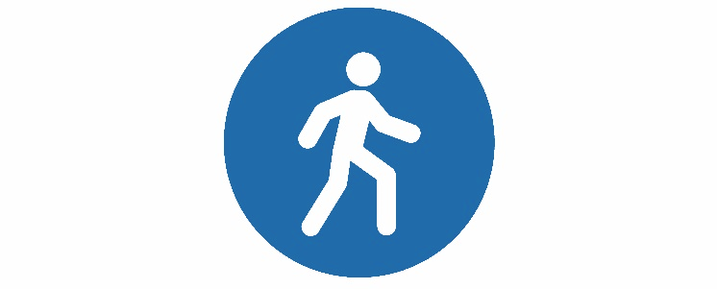

Stay Vertical, Calaveras

CLASS SCHEDULE
Sign up at stayverticalcalaveras@gmail.com or 915-2450
Start | Location | Community | Description | Day | Time
Oct. 1 | Murphys Senior Center | Murphys | Strength Training | Mon & Wed | 9:00 am
Oct. 4 | Murphys Senior Center (full) | Murphys | Tai Chi | Thursday | 10:30 am
Oct. 8 | Murphys Diggins (full) | Murphys | Tai Chi | Mon & Wed | 10:30 am
Oct. 9 | Community United Methodist Church | Valley Springs | Strength Training | Tue & Thurs | 9:30 am
Oct. 9 | Murphys Diggins (full) | Murphys | Tai Chi | Tues & Fri | 10:30 am
Oct. 10 | Pinnacle P.T. (full) | Angels Camp | Strength Training | Wednesday | 1:00 pm
Oct. 15 | Power Up! Fitness | Valley Springs | Tai Chi | Mon & Wed | 10:45 am
Oct. 16 | Power Up! Fitness (full) | Valley Springs | Strength Training | Tue & Thurs | 9:45 am
Oct. 22 | Independence Hall | White Pines | Strength Training | Mon & Wed | 1:00 pm
Oct. 22 | Rancho Calaveras  Club House | Rancho Calaveras | Tai Chi | Monday | 1:00 pm
Oct 22 | Rancho Calaveras  Club House | Rancho Calaveras | Strength Training | Monday | 2:15 pm
Oct. 26 | Power Up! Fitness | Valley Springs | Tai Chi | Friday | 9:45 am

