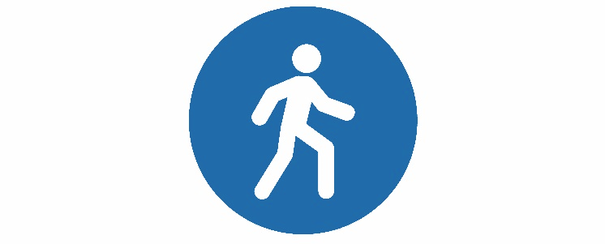

Stay Vertical, Calaveras

CLASS SCHEDULE – SPRING
Sign up by going to www.mthcd.org/stay-vertical-calaveras
or call 915-2450
Start | Location | Community | Description | Day | Time
On-Going | Murphys Senior Center | Murphys | Strength Training | Mon & Wed | 9:00 am
Mar 25 | Murphys Senior Center | Murphys | Tai Chi | Mon  Thurs | 1:00 pm  10:30 am
Mar 25 | Murphys Senior Center | Murphys | Tai Chi | Mon & Wed | 10:30 am
April 1 | The Body Shop | Angels Camp | Tai Chi | Mon & Wed | 10:30 am
April 1 | Power Up! Fitness | Valley Springs | Strength Training | Mon & Wed | 10:45 am
April 2 | Better Together | San Andreas | Tai Chi | Tues & Thurs | 11:30 am
April 2 | Power Up! Fitness | Valley Springs | Tai Chi | Tue & Fri | 9:45 am
April 3 | Library | San Andreas | Tai Chi | Wed & Fri | 12:30 pm
April 3 | Library | San Andreas | Strength Training | Wed & Fri | 1:30 pm
April 8 | Independence Hall | Arnold | Tai Chi | Mon & Wed | 1:00 pm
April 8 | Rancho Calaveras  Club House | Valley Springs | Tai Chi | Mon & Wed | 1:00 pm
April 8 | Community United Methodist Church | Valley Springs | Tai Chi | Mon & Wed | 9:15 am
April 9 | Community United Methodist Church | Valley Springs | Strength Training | Tues & Thurs | 9:30 am

