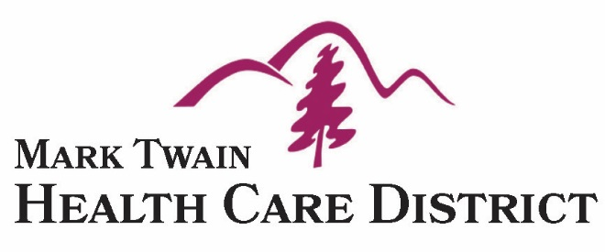

P. O. Box 95
San Andreas, CA 95249 (209) 754-4468 Phone
(209) 754-2537 Fax

Special Finance Committee Meeting
Wednesday December 6, 2017
9:00 am
Mark Twain Medical Center Education Center - Classroom 5
San Andreas, CA

Agenda

Mark Twain Health Care District Mission Statement
“Through community collaboration, we serve as the stewards of a community health system that ensures our residents have the dignity of access to care that provides high quality, professional and compassionate health care”.

1. Call to order:

2. Roll Call:

3. Approval of Agenda: Action

4. Public Comment On Matters Not Listed On The Agenda:

The purpose of this section of the agenda is to allow comments and input from the public on matters within the jurisdiction of the Mark Twain Health Care District not listed on the Agenda. (The public may also comment on any item listed on the Agenda prior to Committee action on such item.) Limit of 3 minutes per speaker. The Committee appreciates your comments however it will not discuss and cannot act on items not on the agenda.
5. Consent Agenda: Action
All Consent items are considered routine and may be approved by the Committee without any discussion by a single roll-call vote. Any Board Member or member of the public may remove any item from the Consent list. If an item is removed, it will be discussed separately following approval of the remainder of the Consent items.
- Un-Approved Finance Committee Meeting Minutes for November 15, 2017:

6. Controller’s Report: Action……………………..………..……………….….…..…………..Mr. Krieg

- Financial Status, Trends, Long-Term Views and Cashflow:

- November Financials Will Be Presented to The Committee:
7. Treasurer’s Report:…………...……………….……..….….….....................…..……….Ms. Atkinson

- Investments:

- Investment Options:

- Investment Policy:

- Reimbursement Policy:

- Auditor’s Report:…………………………..……………….……..………..…………Ms. Atkinson

- Change of Committee Membership :……………………………….……………….Ms. Atkinson

8. Executive Director’s Report:……………………..……….…….……………..……………Dr. Smart

- County Controller Reports:

9. Comment and Future Agenda Items:

10. Next Meeting:

- The next regular meeting will be January 10, 2018:

11. Adjournment: Action

